React is a library not a framework

Dan Abramov, Jordan Walke : lead member who created React

Facebook’s Phantom message problem:



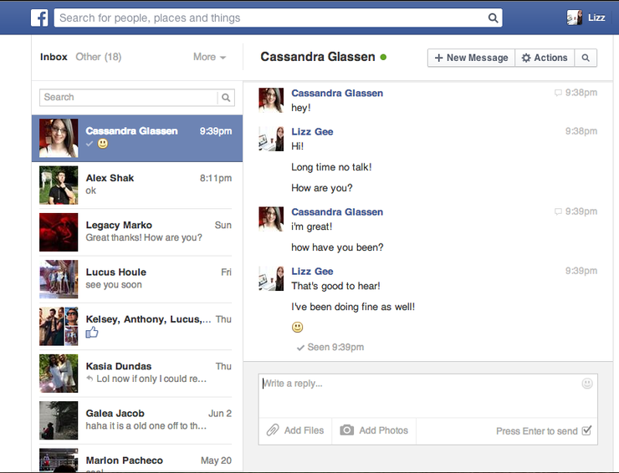

In the notification, the number of messages on the top nav icon was not being updated even after reading the messages.

State (may be variables) managed by JS and UI is managed by DOM.

Now there was no sync between state and UI (inconsistency in UI).

Initially react was hated by the developer community, as a library was created to to solve such a small problem but after many updates and when react became open source many great minds contributed to it and after a conference it started to gain popularity.

It was initially adopted was some famous websites like Khan Academy, Unspalsh etc and then react started to boom.

Core of react:

State or UI manipulation JSX

Component reusability

Props

Propagation of change (Hooks)

Add on to React

React-Router-DOM is not a part of react.

Initially, React didn’t have state management.

To implement state management some other standalone libraries like redux, redux toolkit were introduced

Zustand

Context API

Initially react was class based but now it is functional.

React is not a complete solution, as it does not have seo, also browser render JS and does not have routing.